Assignment 6.4

Problem Statement

Titanic Data Analysis

Write a mapreduce program to find out number of males and females died in the titanic tragedy and save the output in KeyValue Output format.

**Driver Class**

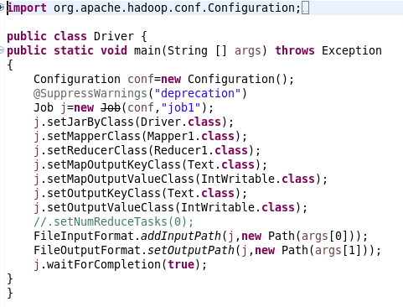

**Mapper class**

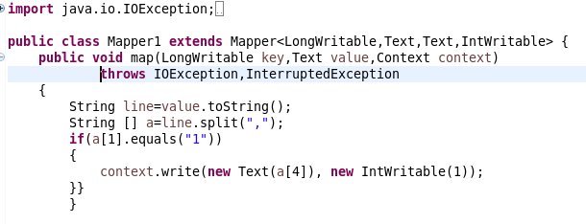

**Reducer class**

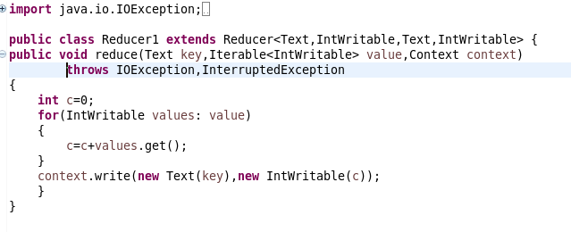

**Jar command**



**Command for output**



**Output**

